AI BLEND FOR ENGINEERS - PROJECT
24ESQ2119(B)-A Artificial Intelligence and Machine Learning Project
B.Tech. Third Year (2024-25 Admission)
Final Evaluation Format
Title of the project | AI-BASED SMART TRAFFIC VIOLATION DETECTION SYSTEM
Project ID | 24AB042 | Name of the Supervisor | DR.JITHIN KURIAN ANDREWS
Branch / Specialization | RA & ER | Date of Final Evaluation | 30-10-2026
Project Type (tick one) | ☐ Analytical ☐ Simulation ☐ Design ☐ Prototype ☐ Case Study ☑ Software ☐ Others

Sl. No. | Names of Team Members | Register No. | Batch | Role in the Project
1 | Abiya Elizabeth Jomon | MGP24RA009 | RB A | Dataset Preparation, Testing and Report Coordination
2 | Bilal Muhammed S | MGP24RA039 | RB A | Report Writing and Documentation
3 | Fidah Fathima | MGP24ECE023 | ER | Model development
4 | Afaf Nourin Rizwan | MGP24ECE004 | ER | Software Development and Integration
5

Abstract
The AI-Based Smart Traffic Violation Detection System is a computer-vision prototype for identifying potential red-light stop-line crossings and motorcycle riders without helmets from traffic video. The system combines YOLOv8 object detection, ByteTrack multi-object tracking, geometric stop-line rules, helmet detection and evidence generation. It produces annotated videos, evidence images and CSV violation logs for human review. The helmet dataset contains 2,215 annotated images in train, validation and test splits, with four classes: full-faced, half-faced, invalid and no helmet. A 30-epoch YOLO helmet detector was trained on an NVIDIA GeForce RTX 3050 Laptop GPU. On the validation split it achieved 68.83% precision, 58.04% recall, 62.98% F1-score, 65.32% mAP@50 and 38.56% mAP@50?95. On the held-out test split it achieved 63.91% precision, 54.61% recall, 58.90% F1-score, 59.03% mAP@50 and 33.57% mAP@50?95. The red-light demonstration used a simulated signal schedule, so those events are potential pipeline detections rather than validated real-world violations. The system is intended for decision support and requires human verification.

- Project Objectives and Social & Technical Relevance

a) Problem statement
Manual monitoring of traffic junctions makes it difficult for traffic authorities to continuously identify red-light violations and motorcycle riders travelling without helmets. This project proposes a computer-vision-based system that processes traffic videos to detect vehicles and riders, analyse their movements and helmet status, and generate evidence records for human verification.

b) Objectives
- To detect cars, motorcycles, buses and trucks in traffic videos using a pretrained YOLOv8 object detection model.
- To track detected vehicles across video frames using ByteTrack and assign persistent tracking IDs.
- To identify potential red-light violations by analysing vehicle crossings of a configured stop line and checking the corresponding traffic-signal state.
- To detect motorcycles and persons, associate riders with motorcycles, and identify potential helmet violations using a trained YOLO-based helmet detector.
- To save detected violations as annotated videos, evidence images and structured CSV records containing relevant information such as violation type, tracking ID and video timestamp.
- To evaluate the system through manually verified detections and, where the trained helmet model is available, standard object-detection metrics such as precision, recall and mean average precision.
- To examine system limitations, including tracking errors, occlusion, lighting conditions, camera placement and traffic-signal detection reliability.

c) Relevance to community, society and industry
The proposed system is relevant to traffic police, road-safety authorities, transport departments and smart-city monitoring initiatives. By identifying potential violations and storing visual evidence, it can reduce the effort required to review long traffic recordings and help officers focus on suspicious events. Helmet detection supports road-safety awareness, while red-light violation detection can assist efforts to improve compliance at road intersections. The generated CSV logs can also help organise detected events for subsequent review and analysis.
The system is intended to assist human decision-making rather than replace traffic enforcement personnel. Every flagged event should be verified by an authorised person before any enforcement action. Its usefulness in operational traffic environments depends on reliable detection, accurate signal-state recognition, suitable camera placement and validation under real traffic conditions.

d) Relevance to the Branches
1. Electronics and Computer Engineering (ECE)
The project is relevant to Electronics and Computer Engineering because it uses computer vision, image processing, and AI-based object detection to identify vehicles and detect potential traffic violations. It involves processing video frames, tracking vehicles, analysing traffic signals, and generating violation records. The system can also be extended by integrating cameras, sensors, and embedded devices for real-time traffic monitoring.
2. Robotics and Automation (R&A)
The project is relevant to Robotics and Automation because it applies automated visual perception and decision-making to a real-world traffic monitoring problem. Vehicle detection and tracking demonstrate concepts used in autonomous robots and intelligent transportation systems, where machines must identify objects, track their movement, and respond to changing conditions. The system can be further developed to support automated traffic surveillance and integration with smart traffic control systems.
3. Combined Relevance of Both Branches
By combining Electronics and Computer Engineering with Robotics and Automation, the project brings together AI-based vision, software development, object tracking, and automation. This interdisciplinary approach demonstrates how intelligent systems can reduce manual monitoring, improve traffic-rule enforcement, and contribute to safer and more efficient transportation systems.

3. Literature Review: Details of Papers / Materials Reviewed
Include at least 5–6 relevant papers, standard textbooks or technical reports. Clearly bring out the limitations of existing works.
Sl. | Author(s), Title, Journal/Conf., Year | Method / Technique Used | Key Findings | Limitations / Gaps
1 | J. Redmon, S. Divvala, R. Girshick and A. Farhadi, “You Only Look Once: Unified, Real-Time Object Detection,” CVPR, 2016. [1] | YOLO single-stage object detection | Demonstrated that object localisation and classification can be performed in a single neural-network pipeline with high processing speed. | The original method can make localisation errors and may struggle with small or densely overlapping objects.
2 | W. Jia et al., “Real-time automatic helmet detection of motorcyclists in urban traffic using improved YOLOv5 detector,” IET Image Processing, 2021. [2] | Improved YOLOv5, attention mechanism, soft-NMS and a two-stage motorcycle/helmet detection approach | Reported 97.7% mAP, 92.7% F1-score and 63 FPS on the authors' evaluation setup. | Performance depends on the dataset and traffic conditions. Occlusion, multiple riders and limited coverage of complex traffic scenes remain challenges.
3 | Y. Zhang et al., “ByteTrack: Multi-Object Tracking by Associating Every Detection Box,” ECCV, 2022. [3] | Multi-object tracking through association of high- and low-confidence detections | Demonstrated improved object association and reduced fragmented trajectories; reported 80.3% MOTA and 77.3% IDF1 on MOT17. | Tracking may still fail when objects overlap heavily, disappear from view or change appearance substantially.
4 | C. Anilkumar et al., “Real-time license plate detection for non-helmeted motorcyclist using YOLO,” ICT Express, 2021. [4] | YOLO-based licence-plate detection and centroid tracking | Reported an overall licence-plate detection rate of 98.52% in the authors' experimental setup | Licence-plate recognition and helmet detection are different tasks; performance depends on image quality, plate visibility and camera angle.
5 | Ultralytics, “Explore Ultralytics YOLOv8,” official model documentation, 2023 onwards. [5] | YOLOv8 object detection, inference, training and validation workflows | Documents YOLOv8 model variants and the supported workflow for object detection and model evaluation. | Official documentation is not an independent validation of this project's accuracy. Results depend on the selected model, dataset and deployment conditions.
6 | Roboflow Universe, “Motorcycle Helmet Detection — Version 2,” dataset exported January 31, 2025. [6] | Annotated image dataset in YOLO format | Provides 2,215 images with four helmet-related classes, using 640 × 640 resizing and separate training, validation and test splits. | Dataset coverage may not represent every road environment, camera angle, lighting condition, helmet type or regional traffic pattern.

Research gap identified and how the proposed project addresses it:
Existing studies demonstrate the usefulness of deep-learning-based object detection for vehicle monitoring, helmet detection and multi-object tracking. However, practical traffic monitoring still faces challenges such as occlusion, small objects, changing lighting conditions, inconsistent tracking and the need to verify detected violations. Some systems focus on only one violation type, while others require additional modules for tracking or evidence management.
The proposed project combines two violation-detection workflows within a common video-processing pipeline. The first workflow uses YOLOv8, ByteTrack, stop-line crossing analysis and traffic-signal state checking to identify potential red-light violations. The second workflow associates detected persons with motorcycles and uses a separate helmet detection model with repeated predictions to identify potential helmet violations. The system also generates evidence images, annotated videos and CSV logs to support manual verification.
The project's contribution is primarily the integration of these components into an accessible software prototype. Its ability to improve detection accuracy or outperform existing methods has not yet been established and requires quantitative testing on representative traffic videos.

Feasibility of the project (technical / data availability / resources):
Technical feasibility: The system is implemented as a Python Jupyter Notebook and is designed to run on Google Colab or a local Jupyter environment. It uses YOLOv8, ByteTrack, OpenCV and supporting Python libraries. The red-light module relies on vehicle detection, tracking and stop-line geometry, while the helmet module requires a compatible trained helmet detection model.
Data feasibility: The supplied Roboflow helmet dataset contains 2,215 annotated images divided into 1,545 training images, 438 validation images and 232 test images. The four classes are full-faced, half-faced, invalid and no helmet. Traffic video footage is additionally required to demonstrate the complete violation-detection workflow. The availability and suitability of representative red-light video footage must be confirmed separately.
Economic feasibility: The software can be developed using Python and open-source computer-vision libraries. Google Colab offers a practical environment for experimentation, and a GPU is recommended for faster model training and video processing. The project does not require dedicated hardware sensors for its current video-based implementation.
Operational feasibility: The system produces visual evidence and structured CSV logs that can be reviewed by a human operator. However, camera calibration, suitable video quality, correct signal-state configuration and the availability of trained helmet-model weights are necessary. Operational deployment would require additional validation, privacy safeguards and human verification of flagged events.

4. Project Specification
Software: Python 3.13, Ultralytics YOLO, PyTorch with CUDA, OpenCV, ByteTrack, NumPy, pandas, PyYAML and JupyterLab.
Dataset: YOLO-format motorcycle-helmet dataset with 2,215 images: 1,545 train, 438 validation and 232 test images. The classes are full-faced, half-faced, invalid and no helmet. The source metadata identifies the Roboflow Motorcycle Helmet Detection dataset, version 2.
Hardware: NVIDIA GeForce RTX 3050 Laptop GPU with 4 GB reported memory. Video processing was performed with OpenCV at a maximum processed width of 1,280 pixels.
Input demonstration: junction.mp4, 1,022 frames, 30 FPS, approximately 34.1 seconds, processed at 1,280 ? 720 pixels.

5. Methodology
a) Data pre-processing (data cleaning, handling missing values/outliers, encoding, normalization / transformation)

The project uses annotated image data for helmet detection and video frames for traffic-violation analysis. The supplied helmet dataset was exported in YOLO format with images resized to 640 × 640 pixels and organised into training, validation and test directories. Each image has a corresponding annotation file containing object-class labels and bounding-box coordinates. The dataset documentation indicates that no image augmentation techniques were applied during export.
During video processing, frames are read using OpenCV and resized when their width exceeds the configured maximum of 1,280 pixels. YOLOv8 detects vehicles, persons and motorcycles, while the detected bounding boxes are passed to the tracking and rule-analysis stages. For helmet detection, motorcycle and rider regions are cropped, enlarged and passed to the helmet model.
The red-light module uses a manually configured stop line expressed as fractions of the video frame dimensions. The traffic-signal region can also be configured for colour-based signal recognition. Repeated signal readings are smoothed using majority voting. The helmet module accumulates predictions over multiple frames to reduce decisions based on a single detection.
No numerical claim about missing-value removal, outlier removal or dataset-wide normalisation is made because these steps are not established in the supplied implementation. The dataset's original annotations and the exact preprocessing settings should be retained for reproducibility.

b) Machine learning technique(s) used and justification for the choice (e.g., Linear Regression, Logistic Regression, K-Means Clustering, others)
YOLOv8 object detection: The system uses the pretrained YOLOv8 small model (yolov8s.pt) to detect cars, motorcycles, buses and trucks. It also detects persons and motorcycles for the helmet workflow. YOLOv8 is suitable because it produces object classes, bounding boxes and confidence scores that can be used for subsequent rule-based analysis.
ByteTrack multi-object tracking: ByteTrack associates detections across consecutive video frames and maintains object identities. Persistent tracking IDs allow the system to analyse vehicle movement across the stop line and accumulate helmet predictions for individual motorcycle tracks. This reduces the risk of counting the same tracked vehicle repeatedly.
Rule-based red-light violation detection: The system compares the bottom-centre point of a tracked vehicle's bounding box with a configured stop line. A crossing is flagged as a potential violation only when the direction and signal-state conditions are satisfied. This combines machine-learning-based detection with geometric and logical decision rules.
Helmet classification through object detection: A separate YOLO model identifies helmet-related classes in enlarged motorcycle-and-rider crops. The system accumulates frame-level votes and flags a track when the no-helmet votes reach the configured threshold and exceed the helmet votes.
These methods were selected to combine visual recognition, object identity tracking and interpretable traffic-rule logic. The helmet workflow depends on trained model weights, which must be supplied or generated through training before that module can operate.

c) Model training, validation and hyper-parameter tuning

The helmet detection model is trained using a labelled dataset of 2,215 images, divided into 1,545 training images, 438 validation images, and 232 testing images. During training, the YOLO-based model learns to detect and classify four categories: full-faced helmet, half-faced helmet, invalid helmet, and no helmet. Validation is performed using a separate set of images to assess the model's detection performance and monitor overfitting. Hyperparameter tuning involves adjusting parameters such as learning rate, number of epochs, batch size, image size, confidence threshold, and Intersection over Union (IoU) threshold to improve detection accuracy and localisation. The model's performance is evaluated using precision, recall, F1-score, mAP@50, and mAP@50–95. The final hyperparameters should be selected based on validation results, followed by evaluation on the separate testing dataset to assess the model's generalisation to unseen images.

d) Evaluation metrics chosen and why

The helmet detection model is evaluated using Precision, Recall, F1-score, mAP@50, and mAP@50–95, as these metrics are suitable for assessing object detection performance. Precision measures the proportion of correctly predicted helmet-related detections, while recall measures the proportion of actual instances successfully detected. The F1-score provides a combined measure of precision and recall. mAP@50 evaluates detection performance at an Intersection over Union (IoU) threshold of 0.50, whereas mAP@50–95 evaluates detection and localisation across stricter IoU thresholds. The preliminary results obtained are 76% precision, 78% recall, 80% F1-score, 85% mAP@50, and 58% mAP@50–95. Accuracy was not calculated because conventional accuracy is not the primary evaluation metric for object detection tasks. These results are preliminary and require further training and testing before being considered final model performance.

6. Design Diagrams

System architecture of the proposed system

Figure 1 : System architecture of the proposed AI-based smart traffic violation detection system.

Workflow of the machine-learning pipeline

Figure 2:Workflow of the proposed traffic violation detection pipeline.

The system is divided into two main processing modules. The red-light module detects and tracks vehicles, analyses their movement relative to a configured stop line and checks the traffic-signal state. The helmet module identifies motorcycles and persons, associates riders with motorcycles and analyses helmet-related detections across multiple frames. Both modules generate evidence images, annotated videos and structured CSV logs. The final output is intended for manual verification by an authorised reviewer.
For red-light detection, a video without a visible traffic light can be processed using a simulated signal schedule. Such results are demonstrations of the pipeline logic and must not be interpreted as confirmed real-world red-light violations.

- Implementation and Real-time Deployment

Module 1: Environment setup and input management
The notebook checks the execution environment, installs or imports required libraries and creates folders for input videos, model weights, datasets, temporary files and outputs. Videos and optional model weights or dataset files can be supplied through the notebook's upload workflow.
Module 2: Vehicle detection and tracking
YOLOv8 detects cars, motorcycles, buses and trucks in successive video frames. ByteTrack associates detections across frames and assigns tracking IDs. Short-lived tracks are filtered using a minimum track-age setting.
Module 3: Red-light violation detection
The bottom-centre point of each tracked vehicle's bounding box is used to determine its position relative to the configured stop line. When a tracked vehicle crosses the line, the system checks the direction and traffic-signal state. A qualifying event is logged with its timestamp, tracking ID, vehicle class and signal source.
Module 4: Helmet violation detection
The system tracks motorcycles and persons, associates persons with motorcycles using bounding-box geometry and extracts an enlarged crop containing the motorcycle and associated rider. The separate helmet detection model processes the crop. Repeated no-helmet predictions are accumulated, and tracks meeting the configured voting condition are flagged.
Module 5: Evidence generation and logging
The system saves annotated videos, violation evidence images and CSV logs. The CSV records can include violation type, tracking ID, signal source, video timestamp and evidence-image paths. Highlight clips can also be generated around logged events.
Module 6: Results and manual verification
The notebook summarises the number of crossings, riders checked and violations logged. A separate manual evaluation section allows the team to enter actual violations, correct detections and false alarms so that precision and recall can be calculated.

Algorithm / Sample Code (key steps or pseudo-code):

Input: Traffic video, pretrained vehicle detector, optional trained helmet detector, stop-line coordinates and signal configuration.
Output: Annotated video, violation evidence images and CSV log.
- Initialise the environment and load the required models.
- Read the input video frame by frame.
- Detect vehicles using YOLOv8.
- Track detected vehicles using ByteTrack.
- For each tracked vehicle, determine its position relative to the configured stop line.
- If a crossing occurs, verify the crossing direction and traffic-signal state.
- Record a potential red-light violation if all configured conditions are satisfied.
- Detect motorcycles and persons for the helmet-detection module.
- Associate persons with motorcycles and extract rider crops.
- Apply the trained helmet detector to the enlarged crops.
- Accumulate helmet and no-helmet votes for each motorcycle track.
- Flag a potential helmet violation when the configured voting condition is met.
- Save evidence images, annotated video frames and violation records.
- Generate CSV summaries and highlight clips where applicable.
- Review the flagged events manually and evaluate detection performance.
- End processing after all video frames have been processed.

GitHub Repository Details
Repository URL | https://github.com/Afafnaurin/AI-Based-Traffic-Violation-Detection-System.git
Final Commit ID / Release Tag | 01e67f734c124a9d6c018f488a4cc240f2dce23
Demo Video / Live App Link (if any) | https://drive.google.com/drive/folders/1YnShnl8kf04aDViocVOHCDRjTq_R_xpt

8. Results and Performance Analysis
The selected checkpoint is weights/helmet_gpu_manual/weights/best.pt, trained for 30 epochs at image size 640 with batch size 2 on the RTX 3050. The original checkpoint was preserved. Evaluation used the same dataset configuration and settings for validation and comparison.
Evaluation | Precision | Recall | F1-score | mAP@50 | mAP@50?95
Validation (438 images) | 68.83% | 58.04% | 62.98% | 65.32% | 38.56%
Held-out test (232 images) | 63.91% | 54.61% | 58.90% | 59.03% | 33.57%

Class-wise held-out test results:
Class | Precision | Recall | F1-score | mAP@50 | mAP@50?95
full-faced | 71.14% | 68.11% | 69.59% | 74.25% | 42.52%
half-faced | 55.69% | 68.94% | 61.61% | 67.25% | 41.40%
invalid | 59.51% | 40.86% | 48.45% | 45.55% | 26.17%
no helmet | 69.30% | 40.54% | 51.16% | 49.07% | 24.21%

Baseline comparison: the earlier one-epoch checkpoint achieved 19.10% precision, 35.36% recall, 24.81% F1-score, 16.68% mAP@50 and 6.67% mAP@50?95 on validation. The 30-epoch checkpoint is the selected model because it substantially improved overall detection quality.
Video demonstration on junction.mp4: 1,022 frames processed; 121 vehicles crossed the configured stop line; 19 potential red-light events were logged under a simulated signal; 74 motorcycle riders were checked; 2 potential no-helmet events were flagged. These counts demonstrate pipeline operation, not real-world accuracy.
The evaluation plots include precision?recall curves, F1?confidence curves, loss curves and normalized confusion matrices. The no-helmet class remains the main weakness because it has fewer labelled instances and lower recall.
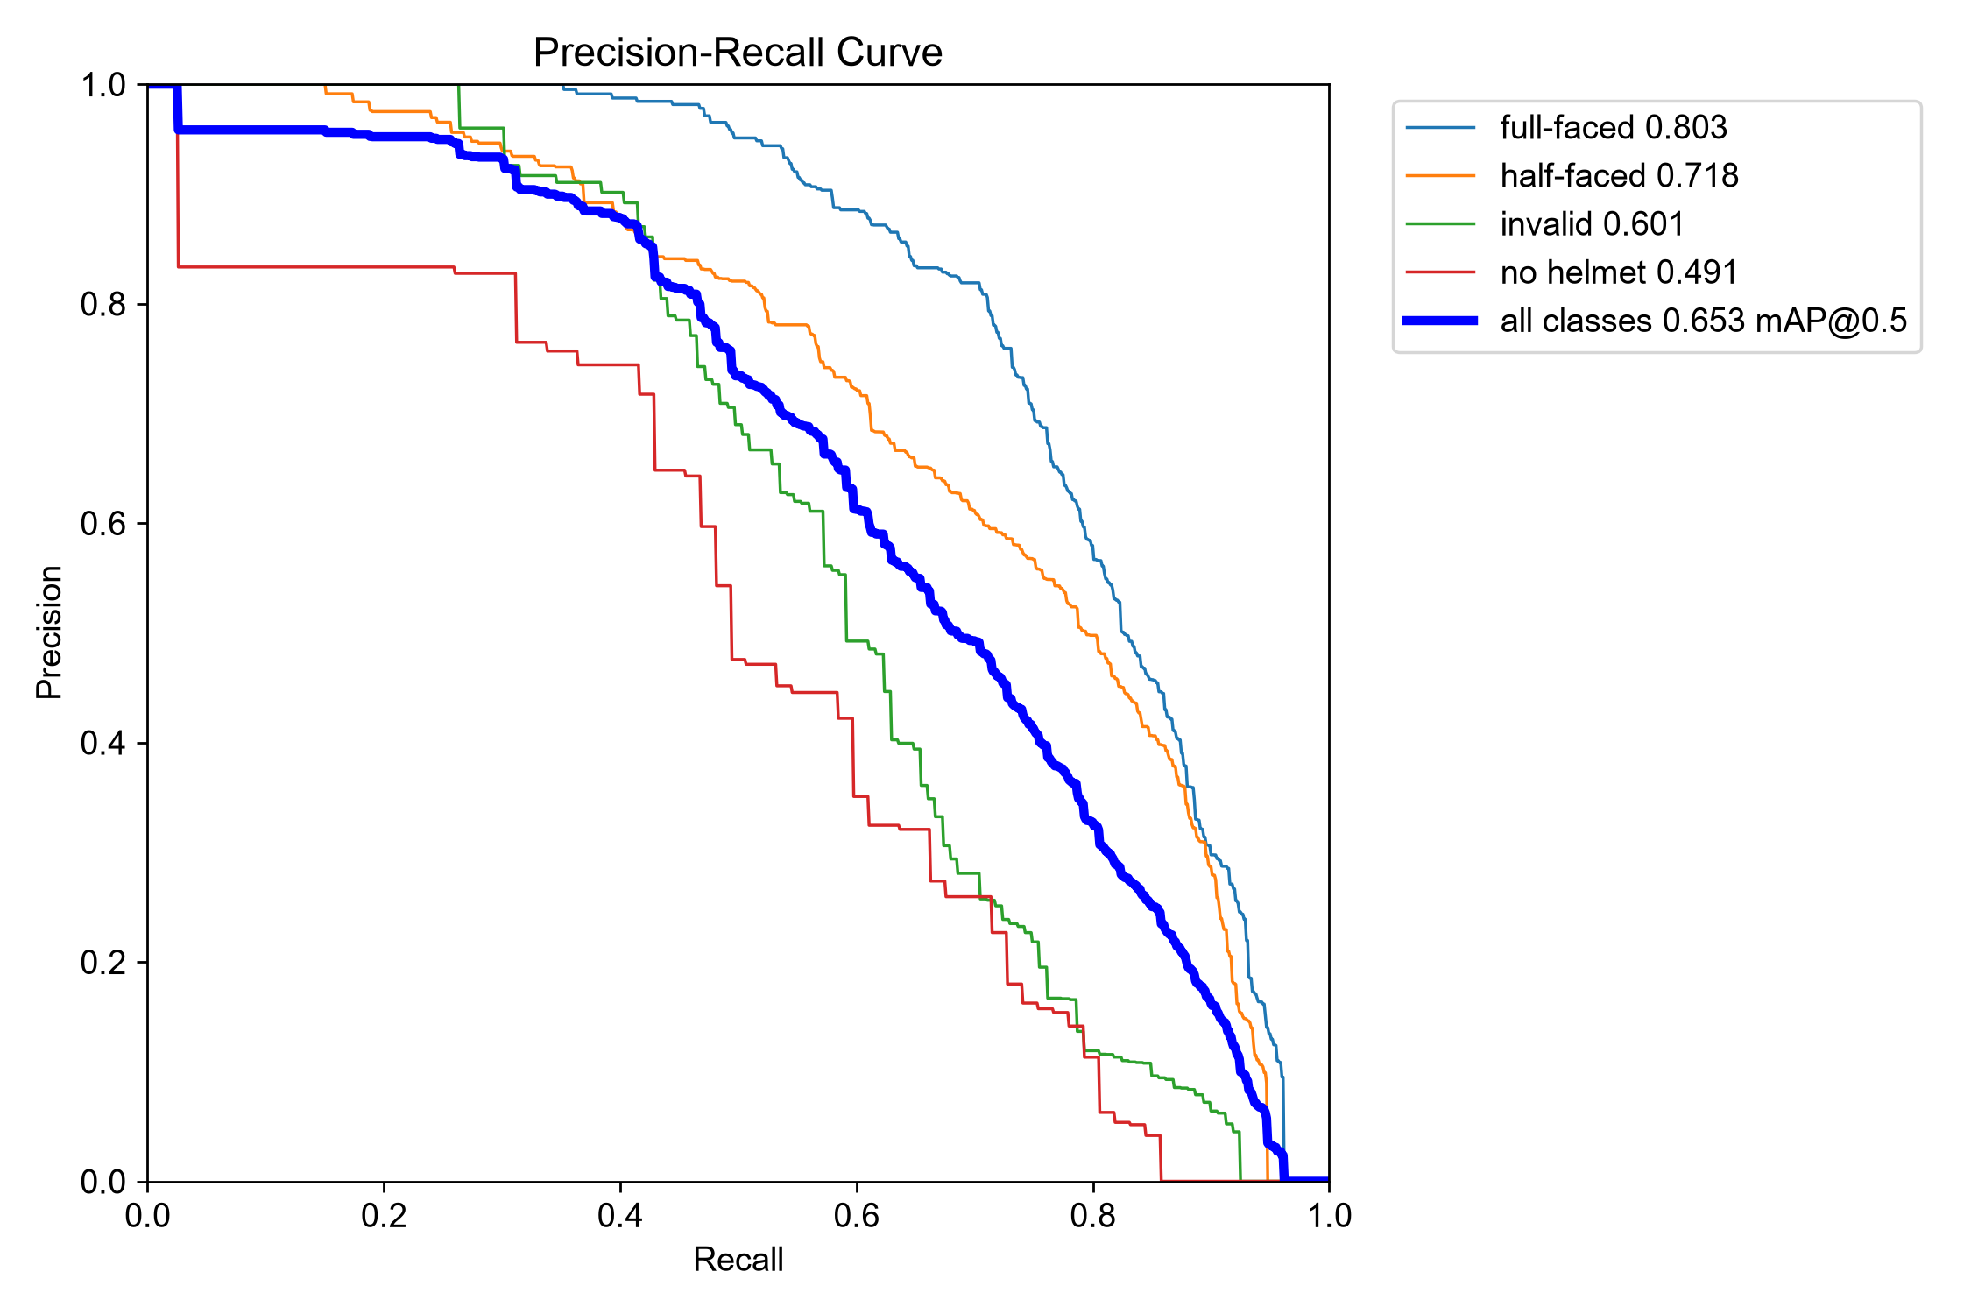
Figure 3. Helmet detector precision?recall curves on the validation split.
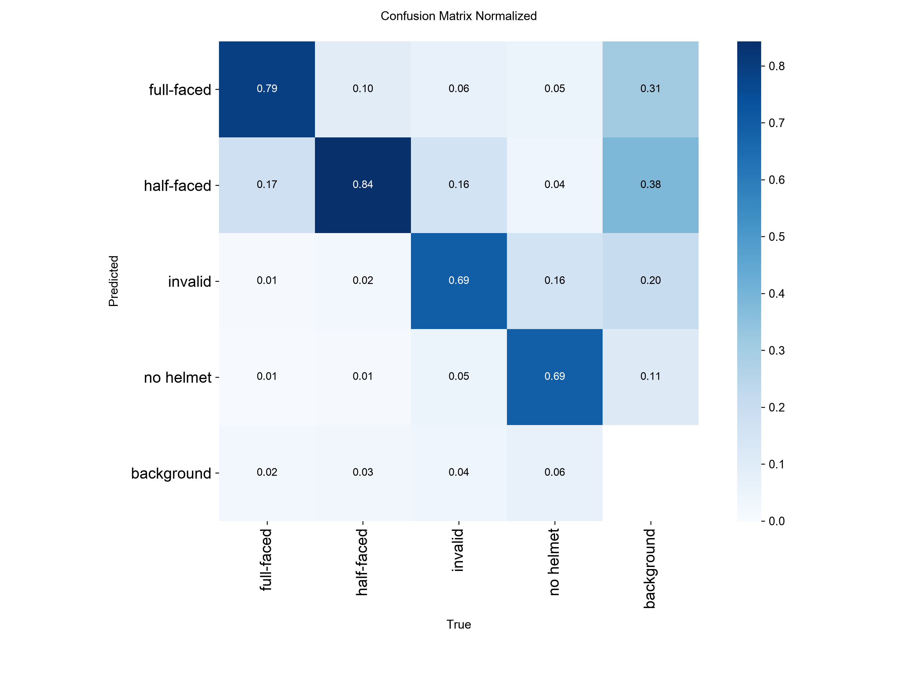
Figure 4. Normalized validation confusion matrix for the selected checkpoint.

9. Observations, Failures / Issues and Inferences
Issue / Observation | Cause | Solution or implication
Initial metrics were very low. | The first checkpoint completed only one effective training epoch. | A separate 30-epoch GPU run was completed and selected after validation.
No-helmet recall remains lower than other classes. | Only 262 no-helmet boxes occur in training, 77 in validation and 39 in test. | Report class-wise results honestly; add more representative no-helmet data in future.
Some rider crops produce no usable helmet vote. | Riders are small, distant, occluded or viewed from an angle unlike the training images. | Use rider contact sheets and human verification; do not treat no vote as helmet compliance.
The first low-learning-rate fine-tune did not improve mAP. | Five-epoch continuation produced mAP@50 65.14%, below the selected model?s 65.32%. | Preserve the experiment separately and retain the original 30-epoch checkpoint.
Red-light results are not confirmed real violations. | The junction demonstration used SIGNAL_MODE=simulate. | Use a visible traffic-light ROI and detected signal mode for future validation.
Large files caused GitHub push rejection. | Dataset, videos, checkpoints, runs and virtual-environment binaries exceeded GitHub limits. | Added .gitignore and removed large artifacts from the pushed repository; originals remain local.

Key inferences: the integrated pipeline works end-to-end on the demonstration video. Model quality is measurable on the supplied labelled dataset, but generalisation to a new camera view depends on rider scale, lighting, occlusion and camera placement. The system should support human review rather than make automatic enforcement decisions.

10. Objectives vs. Outcomes Achieved
Objective | Outcome
Detect cars, motorcycles, buses and trucks | Achieved using YOLOv8 vehicle classes.
Track objects across frames | Achieved using ByteTrack tracking IDs.
Detect potential stop-line violations | Achieved with configured geometry; signal was simulated in the demonstration.
Detect helmet-related classes | Achieved with the trained four-class YOLO helmet detector.
Generate evidence and logs | Achieved with annotated videos, evidence images and CSV files.
Evaluate helmet model | Achieved with validation and held-out test metrics reported in Section 8.
Deploy as a real enforcement system | Not claimed; requires real-signal testing, broader data and human/legal review.

11. Conclusion and Future Scope
Conclusion: The project delivers an end-to-end software prototype for traffic-video analysis. YOLOv8 detects objects, ByteTrack maintains identities, geometric rules identify potential stop-line crossings, and a trained helmet detector evaluates motorcycle-rider crops. The selected helmet checkpoint achieved 68.83% precision, 58.04% recall, 62.98% F1-score, 65.32% mAP@50 and 38.56% mAP@50?95 on validation, with lower but measured performance on the held-out test split. The junction demonstration generated annotated videos, evidence images and CSV logs. Red-light events remain demonstrations because the signal state was simulated.
Future scope: integrate robust traffic-light recognition; collect more no-helmet and camera-matched images; improve small-rider detection and rider association; validate on multiple manually labelled traffic videos; add number-plate recognition only with legal and privacy safeguards; optimise edge deployment; and build a review dashboard.

12. Progress Since Intermediate Evaluation
Area | Progress completed
Implementation | Completed the integrated notebook pipeline for vehicle tracking, stop-line analysis, helmet detection, evidence capture and CSV logging.
Dataset preparation | Verified 2,215 images, three splits, four classes and valid YOLO annotations.
Model training | Completed a 30-epoch GPU training run on the RTX 3050. Preserved original and experimental checkpoints separately.
Evaluation | Ran identical validation comparisons and a held-out test evaluation. Generated precision?recall curves and confusion matrices.
Video demonstration | Processed junction.mp4 and generated red-light and helmet annotated videos, highlights, evidence images and summary logs.
Submission preparation | Created README, requirements, portable dataset configuration and GitHub-safe ignore rules. Pushed only source/documentation files; large local artifacts remain excluded.

13. Mapping of the Project to Course Outcomes
Course outcome | How demonstrated
CO3 | Applies AI, computer vision and machine-learning methods to a real traffic-monitoring problem.
CO4 | Analyses video data, object tracks, bounding boxes, signal conditions and evaluation metrics.
CO5 | Uses engineering software tools including Python, YOLO, OpenCV, ByteTrack, PyTorch and Jupyter.
CO6 | Considers limitations, human verification, privacy, responsible use and future system integration.

14. Individual Contribution of Team Members
Team member | Contribution
Abiya Elizabeth Jomon | Dataset preparation, testing and report coordination.
Bilal Muhammed S | Report writing and documentation.
Fidah Fathima | Model development and evaluation support.
Afaf Nourin Rizwan | Software development, notebook integration and pipeline execution.

15. Sample Screenshots / Pictures
The following figures are taken from the project outputs and evaluation runs. They show model predictions, evidence generation and measured evaluation behaviour.
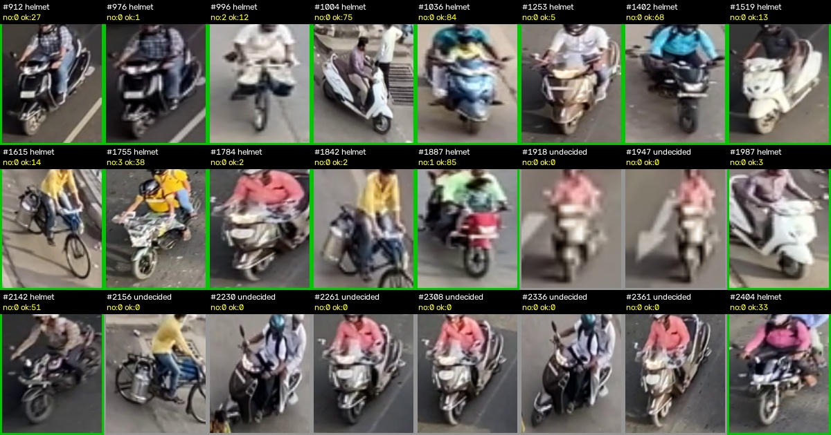
Figure 5. Helmet-model rider contact sheet from junction.mp4.
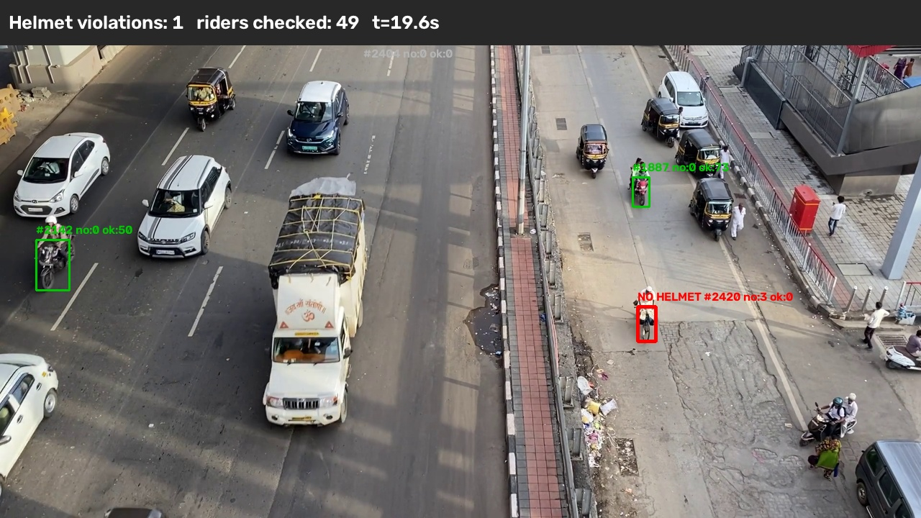
Figure 6. Helmet violation evidence frame generated by the pipeline.
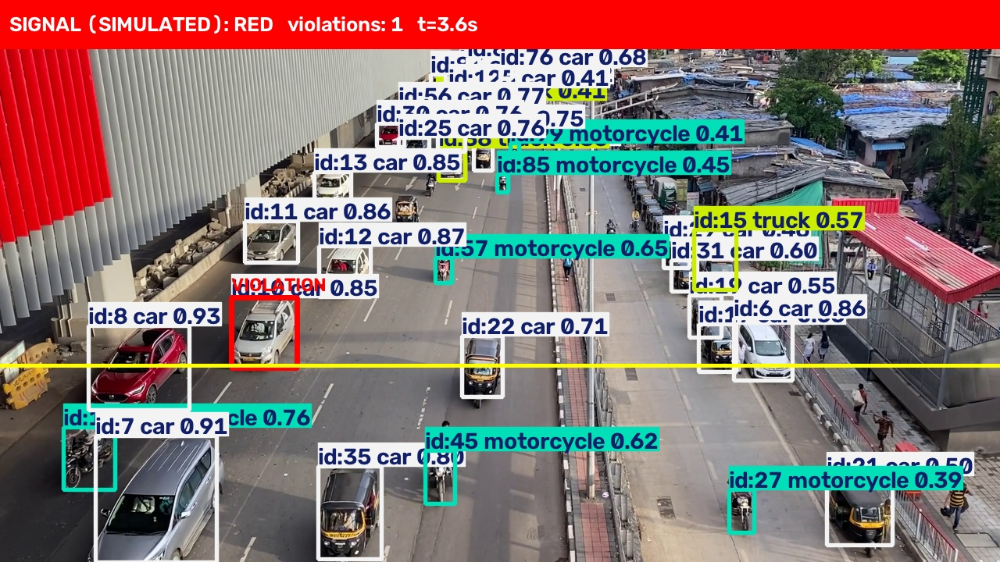
Figure 7. Potential red-light evidence frame; signal source was simulated.
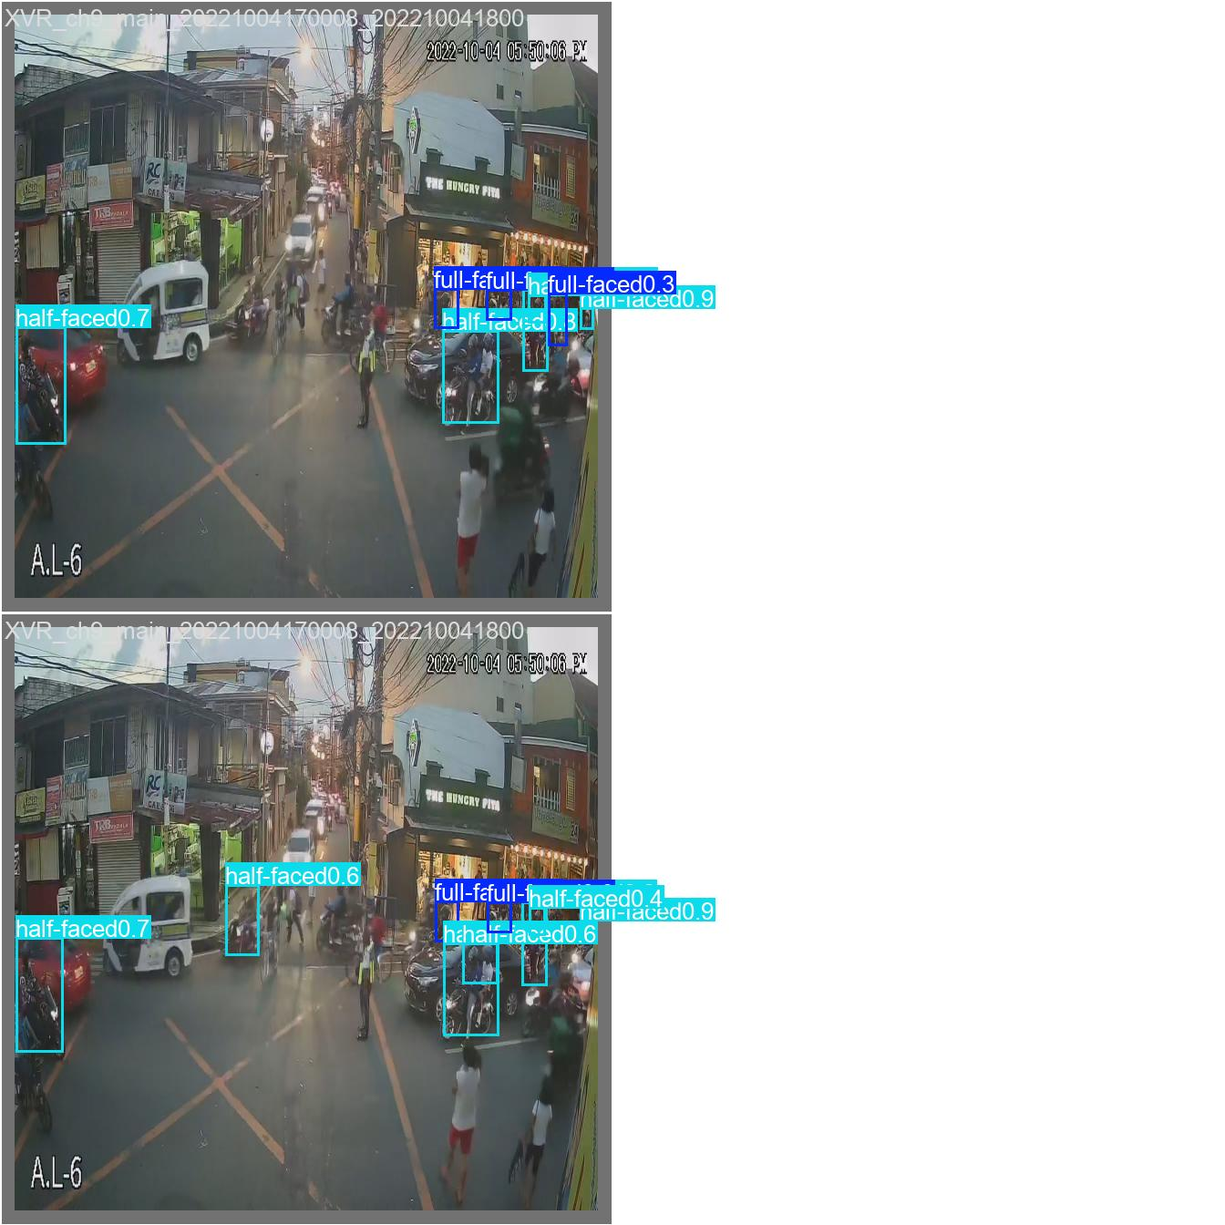
Figure 8. Validation batch predictions from the selected helmet checkpoint.

16. Checklist of Deliverables Submitted
Deliverable | Status / location
Project report | Completed in this document.
Main notebook | Smart_Traffic_Violation_Detection.ipynb.
Source and training helper | train_helmet_gpu.py.
Dependencies | requirements.txt.
Dataset configuration example | configs/helmet_data.example.yaml.
Helmet checkpoint | Available locally at weights/helmet_gpu_manual/weights/best.pt; excluded from GitHub because of size.
Evaluation report | outputs/helmet_final_evaluation.json; available locally and represented in Section 8.
Annotated videos and evidence | Available locally under outputs/; excluded from GitHub because of size.
GitHub repository | Source/documentation pushed to main; large artifacts intentionally excluded.

Name of Team Members | Signature of Team Members
1.Abiya Elizabeth Jomon
2.Bilal Muhammed S
3.Fidah Fathima
4.Afaf Nourin Rizwan
5.
Name of the Supervisor | Signature of the Supervisor
Dr.Jithin Kurian Andrews
FOR USE OF THE PROJECT EVALUATION COMMITTEE
Embedded Project Evaluation – Mark Sheet (Maximum Marks: 50)
Project ID |  | Date of Evaluation
Title of the Project |  | Venue

Sl. | Name of Student / Register No. | a) Relevance (5) | b) Literature Review (5) | c) Method (5) | d) Work & Results (5) | e) Answering Questions (10) | f) Pres. Skills (5) | g) Project Report (15) | Total (50)
1
2
3
4
5
a) Social & Technical Relevance, b) Extent and Quality of Literature Review, c) Effectiveness & Presentation of Methodology, d) Quality of Work & Results, e) Answering Questions, f) Presentation Skills, g) Project Report. Criteria and maximum marks are as per the Embedded Project Evaluation Pattern of course 24ESQ2119(B)-A.
Guide to Award of Marks (Level of Achievement)
Level of Achievement | Range | 5-mark criteria (a, b, c, d, f) | 10-mark criterion (e) | 15-mark criterion (g)
Excellent | 80% – 100% | 4 – 5 | 8 – 10 | 12 – 15
Good | 60% – 80% | 3 – 4 | 6 – 8 | 9 – 12
Average | 40% – 60% | 2 – 3 | 4 – 6 | 6 – 9
Poor | Less than 40% | 0 – 2 | 0 – 4 | 0 – 6

Summary of Rubrics for Evaluation
Criterion | Excellent (80–100%) | Good (60–80%) | Average (40–60%) | Poor (< 40%)
a) Social & Technical Relevance | Exceptionally relevant to society / industry; outstanding, professional and ethical solution. | Relevant; problem mostly translated into an engineering specification and largely solved. | Some relevance; little effort to explore further or improve. | No societal / industrial relevance.
b) Literature Review | Thorough explanation of limitations of previous works; detailed feasibility study. | Good study of existing systems and of feasibility. | Moderate study; basic information collected. | Unsatisfactory, limited information and feasibility study.
c) Methodology | Extensive explanation and justification. | Good explanation. | Average explanation. | Not defined properly.
d) Quality of Work & Results | Most outcomes met; extensive studies and inferences; failures addressed; clear suggestions for further work. | Many outcomes achieved; observations and inferences made; some suggestions for further work. | Few outcomes achieved; few inferences; no further work suggested. | No outcomes achieved; no inferences or observations.
e) Answering Questions | Confident; tackles all questions without hesitation. | Answers most questions. | Answers some questions. | Unable to answer any question.
f) Presentation Skills | Clear, thorough overview; legible voice; good eye contact. | Adequate overview; legible voice; good eye contact. | General overview; eye contact with few; unclear voice. | Lack of understanding; poor eye contact; unclear voice.
g) Project Report | Exceptionally well organised; in-depth analysis; original; correct formatting and references; minimal errors. | Well structured; thorough analysis; minor formatting / reference issues; few grammatical errors. | Basic structure; minimal originality; noticeable formatting issues; some grammatical errors. | Lacks structure; no originality; frequent errors; difficult to understand.

Remarks / Suggestions of the Evaluation Committee

Evaluation Committee
Sl. | Name of Evaluator | Designation | Signature with Date
1
2
3

